

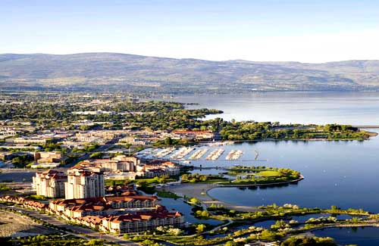
JKA-BC KARATE SUMMER CAMP KELOWNA, B.C.
July 20th -23rd 2017
Camp Description
The focus around the summer camp this year with the Karate World Cup coming up is to further expand your ability, and knowledge in JKA Karate fundamentals. Directly linking these fundamentals into your competition training in advanced kata, and kumite.

The second goal of the seminar is giving an opportunity for our members from beginner to our most advanced Black belts to take exams. Exams will be offered from 9th kyu to 1st kyu, Shodan and Nidan, as well as D level for all three of the JKA Instructor credentials program.

Reminder the purpose is to struggle by strenuous effort for the betterment of manners and techinque and to cultivate friendship among participants.

Contact info: info@kelownakarate.ca (250)-870-3662
INSTRUCTOR INFO:
Chief Instructor- Sensei Don Sharp, JKA 6th Dan
1996 World Cup Champion, World Championship WKF Silver medalist 1997, 11 time National Champion, JKA A level Instructor, B level Judge, B level examiner, 3 time Canadian Martial arts Athlete of the year.
Assistant Chief Instructor- Sensei Paul Atkin, JKA 4th Dan
Current JKA National team member, Bronze men's kumite JKA National Championships, mixed national team 2001, 2006 Ozawa Cup team kumite gold champion, Silver individual kumite champion, 11 time provincial champion, 5 time Provincial team member.
Additional Instructors- Sensei Mike Doherty 5th Dan JKA, Sensei Sal Sharp 5th Dan JKA, Sensei Graham Mallet 4th Dan JKA, Sensei Harry Sidhu 4th Dan JKA, Sensei Ashraf Omeria 4th Dan JKA, Sensei Joe Lappan 3rd Dan JKA, Sensei Brock Smith 3rd Dan JKA

Special Guest Instructor!!!!!!!!!!
Can you guess who will be our guest instructor??

REGISTRATION INFO-
Early Bird Special Registration: (Before Saturday July 8th 2017)
Juniors-$95.00 full seminar or $20.00 per class.
Adults-$120.00 full seminar or $25.00 per class.
Adults 1st kyu & up-$130.00 full seminar, $25.00 per class.

Same Day/ Late Registration (After Saturday July 8th 2017)
Juniors-$115.00 full seminar, $25.00 per class.
Adults-$145.00 full seminar, $30.00 per class.
Adults 1st kyu & up-$155.00 full seminar, $30.00 per class.

All members over the age of 4 years old can participate.
If you have registered for the full seminar the beach class is included!!
If you're not attending the full-seminar the beach class is only $15.00 extra.
Payment Information:
-Please make cash or cheque payable to Kelowna Karate and Fitness Inc.
-Payment in for Early Bird Special by Saturday July 8th 2017 or pay the late registration fee amount.
-If clubs can collect, and fill out all club registration and issue 1 cheque please.
Thank you.
Mailing address-#10-1925 Kirschner Rd. Kelowna, B.C. V1W-4N7
II. DAN/KYU GRADINGS
-Follow JKA-BC protocol for preparation for grading.
-Grading time scheduled for Saturday July 22nd at 1:00pm at Kelowna Karate Dojo.

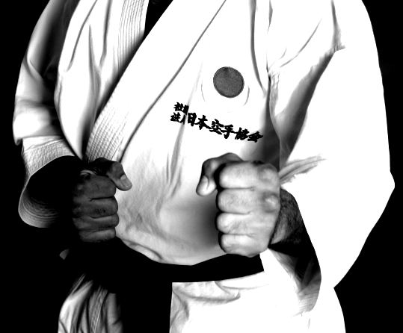
III.LOCATIONS
A.) DOJO
#10-1925 Kirschner Rd. Kelowna, B.C. V1W-4N7
B.) ARENA
Central Sports Club, 1155 Ellis St. Kelowna B.C.
C.) GYRO BEACH/PARK
Gyro Beach at 3400 Lakeshore Rd.
D.) SUMMER CAMP PARTY (BODO'S HOUSE)
2620 Alberta Court. Kelowna, B.C.

IV. KIDS TOTAL AMOUNT OF CLASSES (4-14 YEARS OLD)
White to Purple belt -6 classes (plus beach class.)
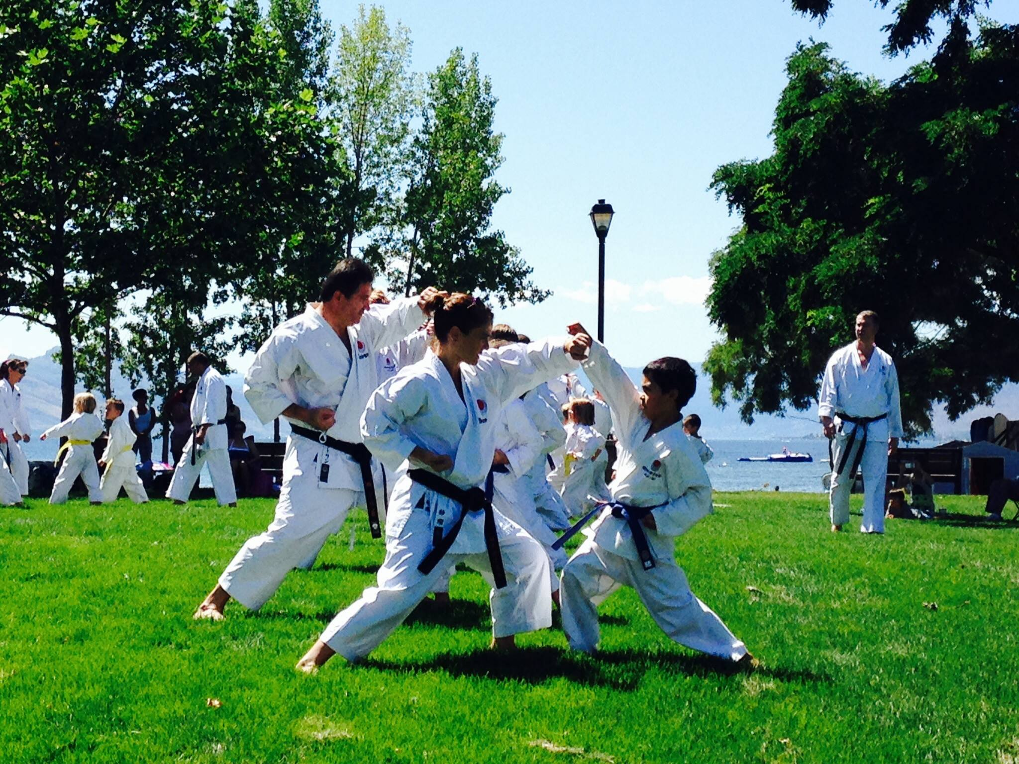
Brown belt -8 classes (plus beach class.)
Black black belt -8 classes (plus beach class.)

V. ADULT TOTAL AMOUNT OF CLASSES
White to Purple belt -6 classes (plus beach.)
Brown belt-8 classes (plus beach.)
Black belt- 8 classes (plus beach.)

BEACH CLASS INFORMATION
Located at Gyro Beach at 3400 Lakeshore Rd. in the Mission from 1:00-2:00pm.
Expect to get your dogi (uniform) wet!!!
(Training area will be located far left side of the beach, next to water activity retails.) Make sure to be early for parking, and your invited to stay and socialize with your fellow Karate-ka.

VI. PRE-ORDER SUMMER CAMP T-SHIRTS
$25.00 for t-shirt $25.00 tank top $45.00 polo -t-shirt
(Pre-order's ensure you get your size.) Must have order in by July 1st 2017.
Limited amounts, and sizes will be available at the camp for sale, so make sure to
pre-order to ensure you get one. Thank you.

VII. ACCOMODATION

SUPER 8 MOTEL
2592 Hwy 97 North, On Hwy 97 near Hwy 33
Kelowna, BC,V1X4J4, Canada‎

Arrive: Thursday July 20th
Departure: Sunday July 23rd
Number of rooms reserved under Kelowna Karate:15
Room Types:

Double room: 2 double beds 4 guests.
Single room: 1 Queen bed 2 guests.
Nightly rate-$134.99/night, plus taxes $20.25
Total/room night $155.24/per night
super8kelowna@shaw.ca
call (250)-762-8222, 1-800-563-0991

Room Features:
All of our rooms are equipped with a mini fridge, hair dryer and a coffee machine with complimentary tea and coffee.

Our property is proud to offer free wireless Internet throughout the property, and free local and 1-800 calls.
Our complementary Continental breakfast includes bagels, toast, cinnamon rolls, hard boiled eggs, toaster waffles, yogurt, a variety of cereals, oatmeal, fresh fruit, apple and orange juice, coffee, tea and hot chocolate.
There is a microwave in our lobby available for guest’s use any time. We have a seasonal outdoor pool and year-round hot tub that will be open daily from 10 am to 10pm.SE NOTE- The release date for the block of rooms would be one month before the arrival date- July 1st, 2016. Make sure to mention that you are with The Kelowna Karate to receive discount rat
CAMPING GROUNDS:
Willow Creek Family Campground 3316 Lakeshore Rd, Kelowna- (250)-762-6302
Hiawatha R.V. Park 3795 Lakeshore Rd, Kelowna-(250)-861-4837
Kelowna Karate Parking Lot is also available for people with recreational vehicles that would like to use. Please email Sensei Paul to book a spot for free. info@kelownakarate.ca
HOMESTAY: ( Please notify Paul Sensei by July 1st if possible for limited spots.)
Out of town members please email Paul Sensei at www.kelownakarate.ca with:
how many many in your group?
Are you a family/kid/adult(male/female)? Are you allergic to any pets?

JAPAN KARATE ASSOCIATION OF BRITISH COLUMBIA
SUMMER CAMP SCHEDULE
THURSDAY July 20th
CLASS. 1 | CLASS.1
5:00-6:15PM  KIDS  White to Green  Techincal Director  Dojo 1st floor | 5:00-6:15PM  KIDS  Blue to Brown  Technical Director  Dojo 2nd Floor
CLASS.2 | CLASS.2
6:30-7:45PM  ADULTS  White to 2nd Kyu Brown  Technical Director  Dojo 1st floor | 6:30-7:45PM  ADULTS  1st Kyu to All Black belts  Technical Director  Dojo 2nd Floor

FRIDAY July 21st
CLASS.1
10:11:15AM
KIDS
All belt levels
Technical Director
Gyro Beach (Far left side on the grass.)
CLASS.2
11:30-1:00PM
KIDS/ADULTS
Brown/ Black belts
Technical Director
Gyro Beach (Far left side on the grass.)
CLASS.3 | CLASS.3
5:00-6:15PM  KIDS  White to Green  Technical Director  Dojo 1st floor | 5:00-6:15PM  KIDS  Blue to Brown  Technical Director  Outside dojo mats
CLASS.4 | CLASS.4
6:30-7:45PM  ADULTS  White to Brown  Technical Director  Dojo 1st floor | 6:30-7:45PM  ADULTS/YOUTH  Black belt/ Dan Candidates  Technical Director  Dojo 2nd floor

SATURDAY July 22nd
CLASS.1
9:00-10:15AM
KIDS & ADULT
All belt levels
Technical Director
Arena
CLASS.2
10:30-12:00PM
Arena
KIDS  White to Green  Technical Director | ADULT  White to Green  Technical Director | ADULT/KIDS  Blue to Purple  Technical Director |  | ADULT/KIDS  All Brown belts  Technical Director | ADULT/YOUTH  Black belts only  Technical Director
KYU/DAN GRADINGS
1:00-2:15PM
Dojo 2nd Floor
CLASS.3
1:15-2:30PM
ADULTS
White to Purple
Technical Director
Dojo 1st Floor
CLASS.4
2:45-4:00PM  Kids under the age of 12  White to Purple  Technical Director  Dojo 2nd floor |  |  | 2:45-4:00PM  Adult/Youth  Brown and Black belts  Technical Director  Dojo 1st floor
PARTY AND GRADING RESULTS
6:00-9:00PM

SUNDAY July 23rd
CLASS.1
9:45-11:OOAM  ADULTS  White to Purple  KIDS:Purple only  Technical Director  Dojo 1st floor | 9:45-11:15AM  ADULTS  Brown/Blackbelts  Instructors Course  Sensei Don Sharp  Dojo 2nd Floor
CLASS.2
11:15-12:15PM  KIDS/ADULT  Brown/ Black belt  Technical Director  Dojo 1st Floor & 2nd Floor | 11:15-12:15PM  (TBD)
BEACH CLASS
1:00-2:00PM
KIDS/ADULTS
ALL MEMBERS!!
White to Black
Technical Director
(gyro beach far left side)

JAPAN KARATE ASSOCIATION OF BRITISH COLUMBIA
SUMMER CAMP CLUB REGISTRATION LIST
NAME | AGE | RANK | HOW MANY CLASSES | FULL SEMINAR | T-shirt $25  Tank top shirt $25  Polo T-shirt $45  Junior or Adult Male/Female  sizes:XS,S,M,L,XL | AMOUNT
John Smith  EXAMPLE | 9 | 7th kyu  Orange belt | 6  + Beach | FULL | Junior t-shirt Small | $120.00  EXAMPLE
Amy Dow  EXAMPLE | 34 | 1st kyu  Brown belt | 8  + Beach | FULL | Adult female tank top  Medium | $155.00  EXAMPLE
Tim Smith | 36 | Shodan | 8  + Beach | FULL | Adult Male polo-shirt  X-Large | $200.00  EXAMPLE
 |  |  |  |  |  | Total:

